
STUDENT NAME: SHEIKH FARDOSA JIBRIL
ADMISSION NUMBER: BSCCS/2024/54679
COURSE: COMPUTER SCIENCE
UNIT CODE: BIT 3208
UNIT NAME: ADVANCED WEB DESIGN AND DEVELOPMENT
LECTURERS NAME: NYORO MICHAEL
SEMESTER: 3,2

PROJECT DETAILS
PROJECT TITLE: Smart Task & Study Management System
SELECTED TECHNOLOGIES:
HTML
CSS
JAVA SCRIPT
PHP
MYSQL
XAMPP

TABLE OF CONTENTS
Contents
WEEK 1: LOCAL ENVIRONMENT SETUP 4
INSTALLATION AND TESTING OF LOCAL ENVIRONMENT SEETUP 4
Fig 1: installation of XAMPP 4
Fig 2: shows Apache and mysql running 5
Fig 3: localhost test page 5
6
Fig 4: hello world test 6
Fig 5: database connection test 6
WEEK 2 : WIREFRAMES AND GUI DESIGN 7
Title : user interface planning and system design 7
Fig 6: Hand drawn wireframe showing login page 7
Fig 7: showing dashboard layout design 8
Fig 8: Mobile view mockup 8
Fig 9: shows the login page in canva 9
WEEK 3: JAVASCRIPT AND PHP BASICS 11
TITLE: Frontend Interactions And Backend Foundations 11
Week 4 : 14
server side components and backend development functions 14
Fig 17: shows login.php 15
Fig 13:shows database to enter information 16
Fig 15: showing sample of the dashboard 16
Week 5: 18
Database components and crude operations 18
Figure 5.1: Database structure showing the available tables in the smarttask database. 18
Figure 5.2: Structure of the users table showing the fields and data types. 18
CRUD OPERATIONS 19
Figure 5.4: Records displayed in the users table (Read operation 19
Figure 5.5: SQL UPDATE query used to modify an existing record in the users table 19
Figure 5.4: SQL DELETE query executed to remove a record from the users table. 20
Figure 5.5: Login interface used for database authentication. 20
Week 6 Database Integration and CRUD Operations 21
PHP Database Connection 21
Figure 6.1: PHP script establishing a connection to the MySQL database. 21
Figure 6.2: Data entry form used to create new records 22
Figure 6.3: Records retrieved and displayed from the database. 22
Figure 5.5: Successful user login demonstrating database integration between the web application and the MySQL database 23
WEEK 7: User Authentication and Session Management 23
Users Table for Authentication 23
Student Authentication and Session Management 24
Teacher Role-Based Authorization 25
Super Administrator Role-Based Authorization 25
Logout Functionality 26
WEEK 8: Responsive Web Design and Mobile-First Development 27
Desktop View 27
Tablet view 28
Mobile View (Mobile-First Design) 29
CSS Media Queries Implementation 30
Responsive Testing 31

WEEK 1: LOCAL ENVIRONMENT SETUP

INSTALLATION AND TESTING OF LOCAL ENVIRONMENT SEETUP

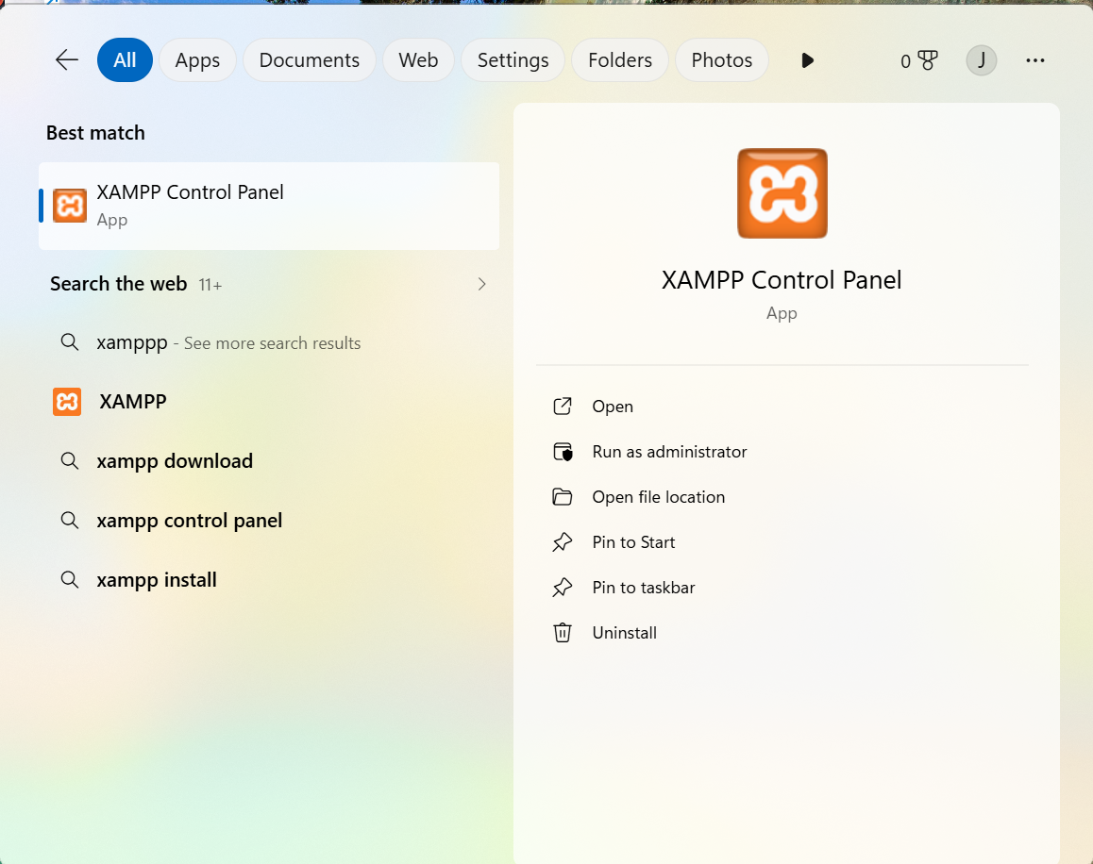

Fig 1: installation of XAMPP

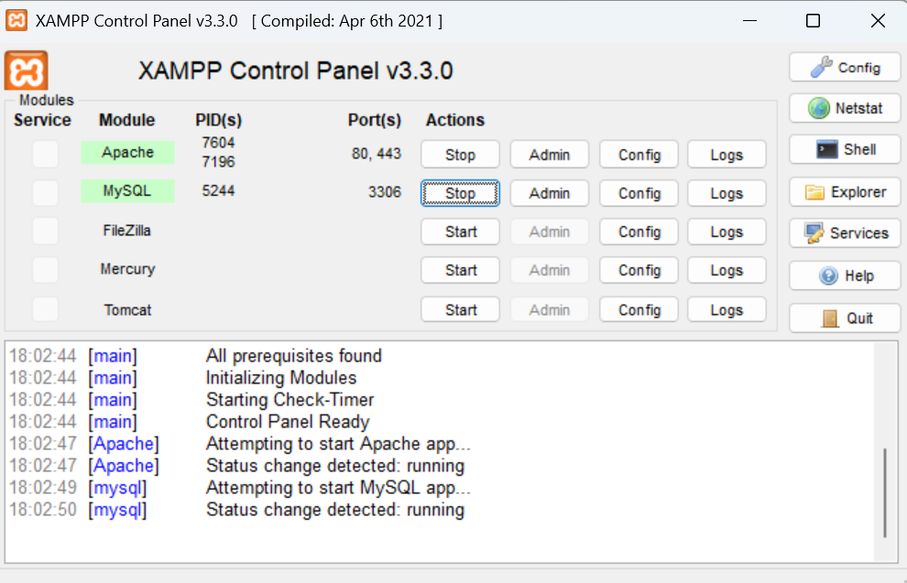

Fig 2: shows Apache and mysql running

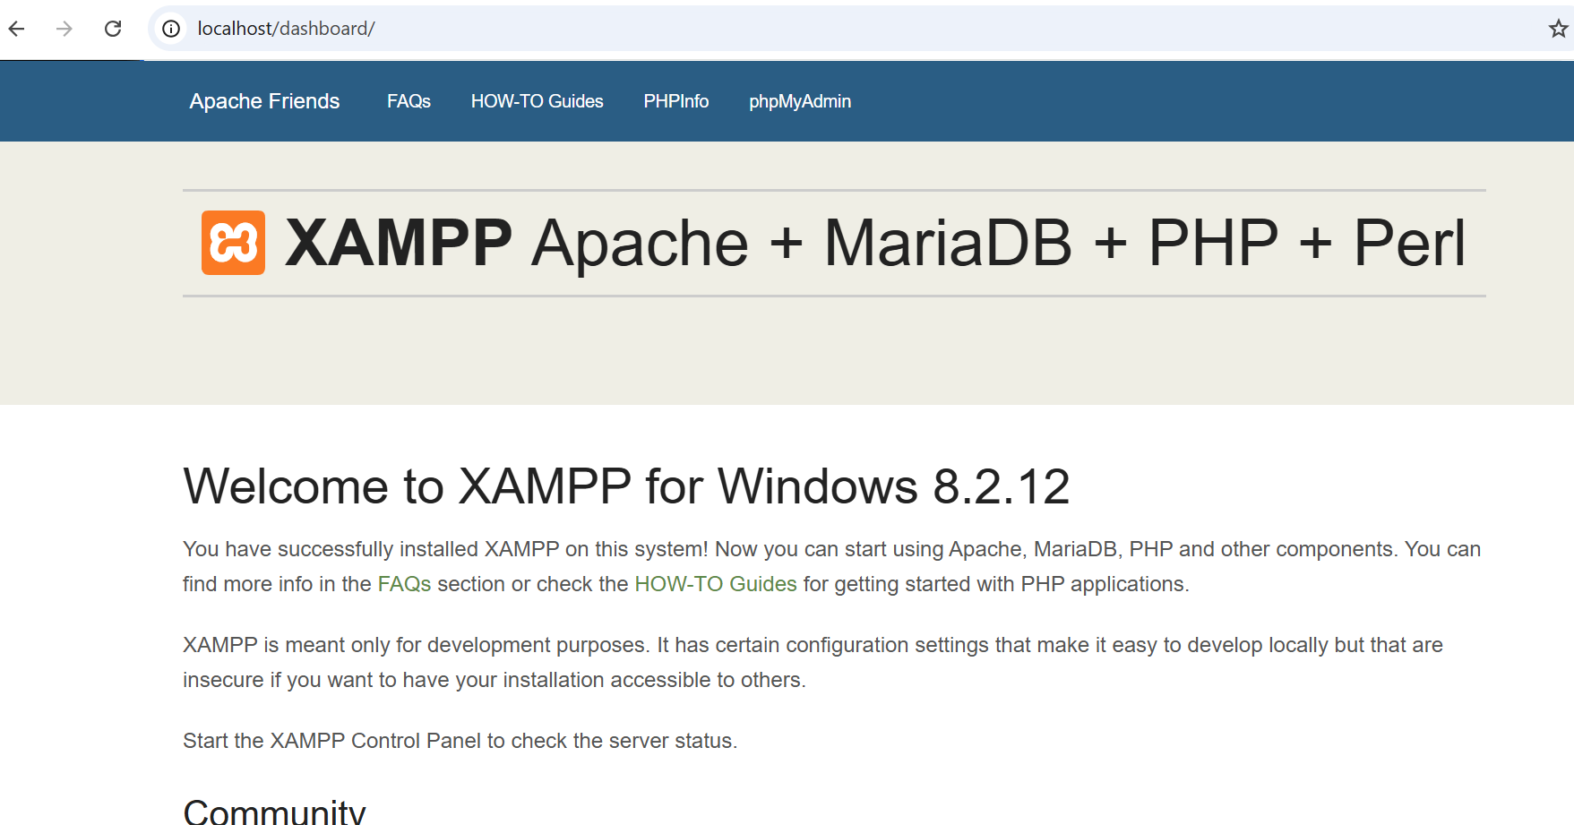

Fig 3: localhost test page

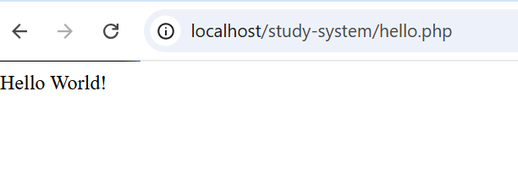

Fig 4: hello world test

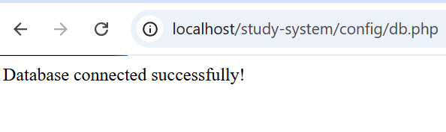

Fig 5: database connection test

STUDENT REFLECTION
The installation process involved setting up XAMPP to enable a local server environment for PHP and MySQL. A “Hello World” test confirmed PHP was running correctly through localhost. A database connection test using phpMyAdmin verified successful communication between PHP and MySQL, demonstrating how web applications interact with backend servers and databases.

WEEK 2 : WIREFRAMES AND GUI DESIGN

Title : user interface planning and system design

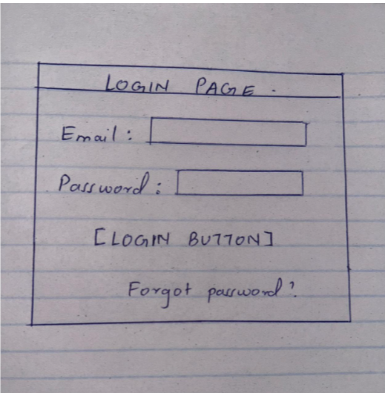

Fig 6: Hand drawn wireframe showing login page

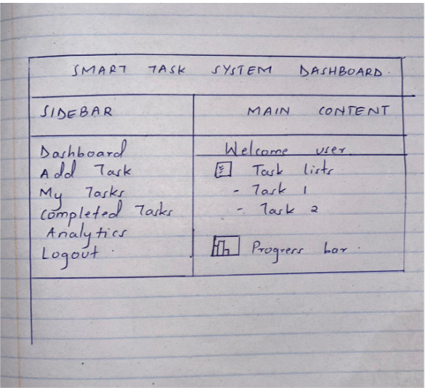

Fig 7: showing dashboard layout design
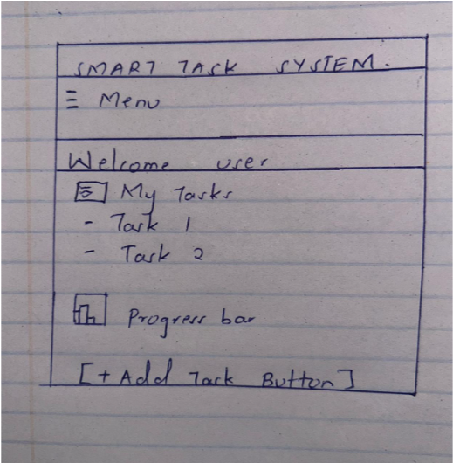

Fig 8: Mobile view mockup

COLOR THEME AND NAVIGATION STRUCTURE
Colour theme
Primary color : white
Secondary color : black
Accent color: red
Background color: light grey
Text color : black
Navigation structure
Sidebar navigation for desktop
Top menu for mobile
Links:
Dashboard
Add task
Completed task
Analytics
logout
GUI PROTOTYPE IN CANVA
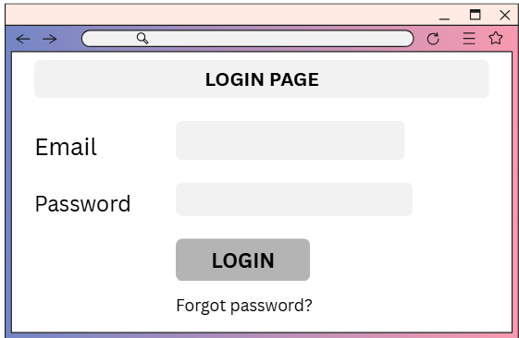

Fig 9: shows the login page in canva

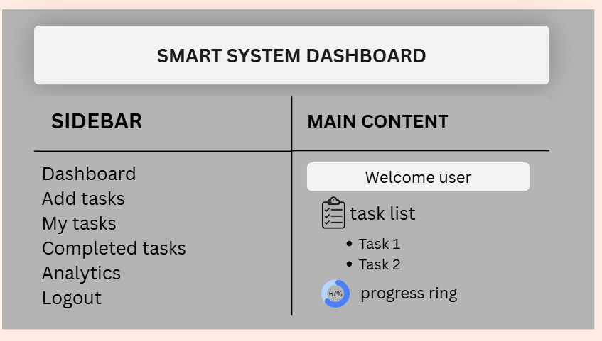
Fig 10: shows the dashboard made in canva

STUDENT REFLECTION
The design was selected to provide a simple, organized, and user-friendly interface for managing study tasks and monitoring productivity. User experience was considered by creating clear navigation, readable layouts, and responsive mobile views. The navigation flow was planned to allow users to move easily between the dashboard, task management, analytics, and account functions with minimal effort. The system is intended for students who need an efficient way to organize assignments, track progress, and manage their study schedules. The layout also allows for future expansion as additional features and modules are introduced.

WEEK 3: JAVASCRIPT AND PHP BASICS

TITLE: Frontend Interactions And Backend Foundations
Javascript form validation
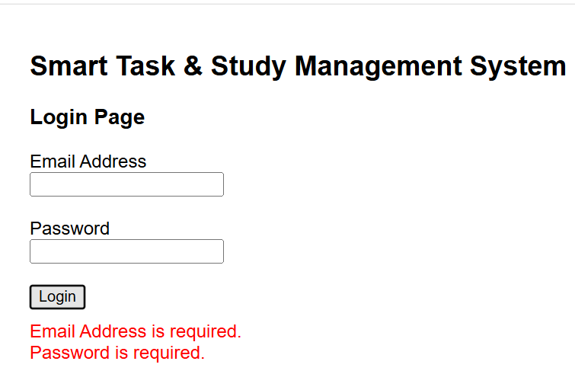
Fig 10: Javascript form validation

Password strength checker
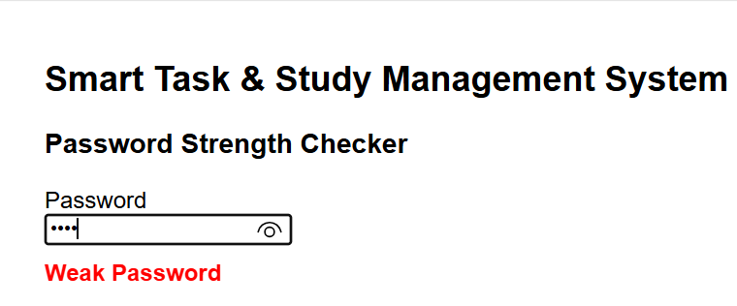
Fig 11: password strength checker using javascript

Php syntax practise
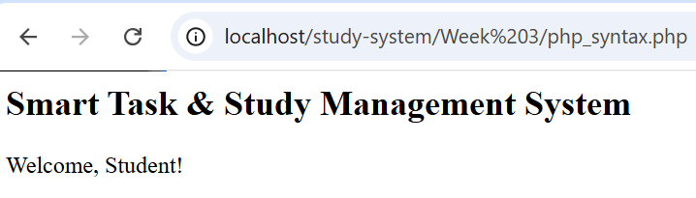
Fig 12: show php running correctly in XAMPP

Database connection script
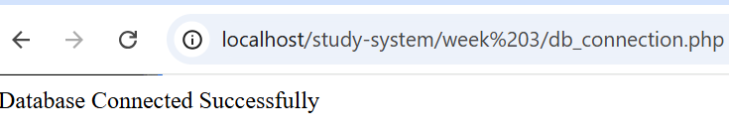
Fig 13: php successfully connected to mysql

Dynamic user input handling
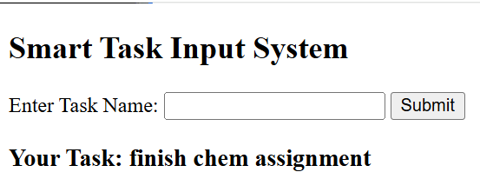
Fig 14: system takes user input and dynamically displays it using php

Student evaluation
Week 3 focused on practical implementation of core web development concepts using JavaScript, PHP, and MySQL. JavaScript was used to perform form validation and password strength checking to improve user input quality and security. PHP was applied to understand basic syntax and server-side processing, including handling user input dynamically. A database connection script was also developed to demonstrate communication between the application and MySQL. This phase helped reinforce understanding of how frontend and backend technologies work together in building interactive and data-driven web systems.

Week 4 :

server side components and backend development functions

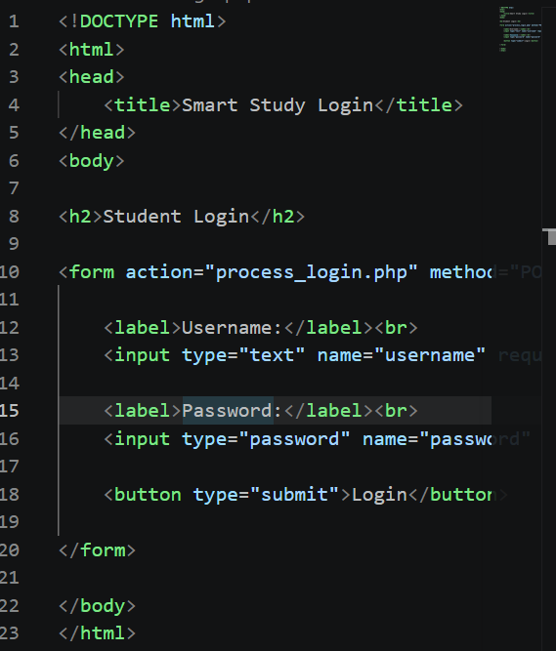

Fig 17: shows login.php

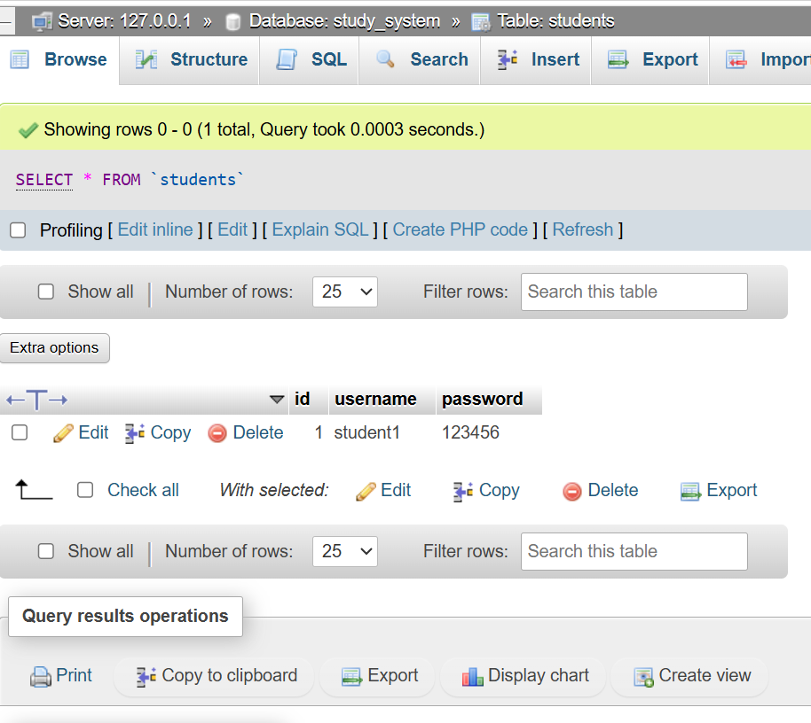

Fig 13:shows database to enter information

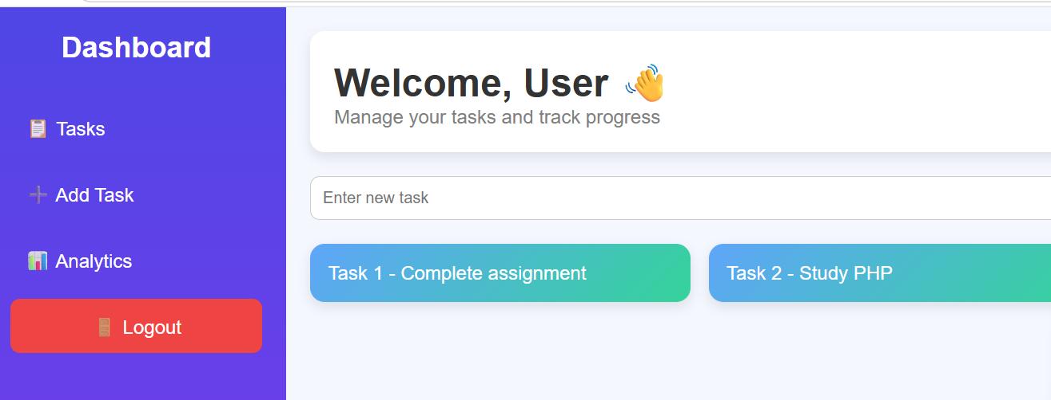

Fig 15: showing sample of the dashboard

Student evaluation
During Week 4, I developed a simple Smart Study and Management System using PHP and MySQL. The main focus was to understand how frontend forms communicate with backend scripts and how data is processed on the server side.The system includes a basic login module, a database connection, and a dashboard page. I created a MySQL database named study system with a students table that stores usernames and passwords. This helped me understand how data is stored and retrieved from a database using SQL query

Week 5:

Database components and crude operations

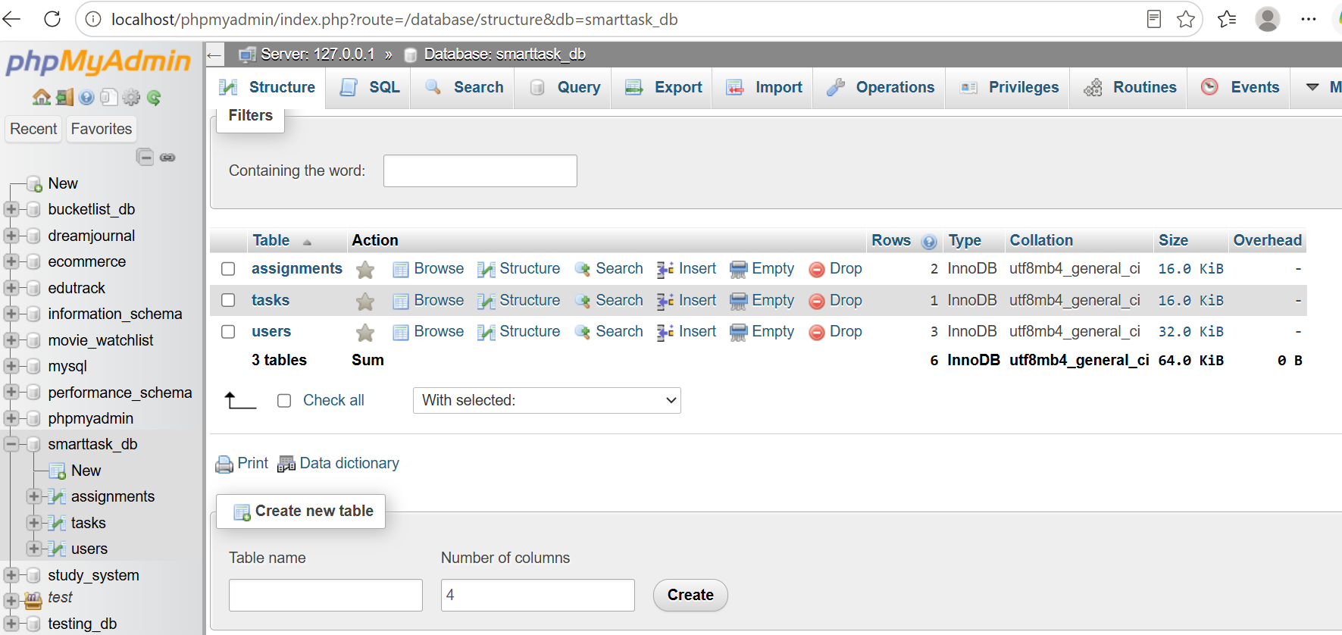

Figure 5.1: Database structure showing the available tables in the smarttask database.

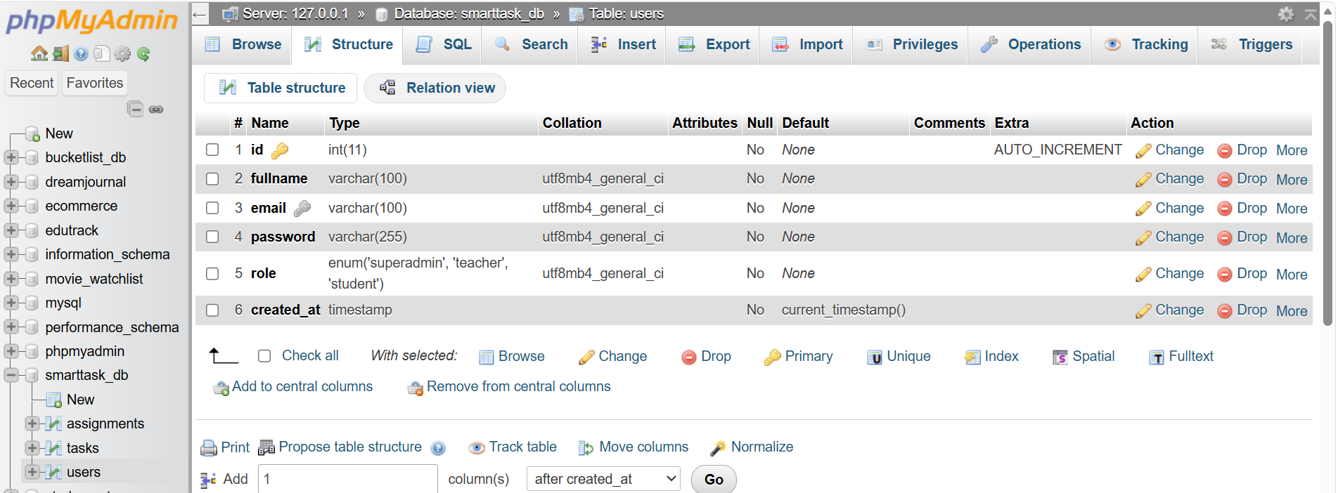

Figure 5.2: Structure of the users table showing the fields and data types.

CRUD OPERATIONS
Create operation
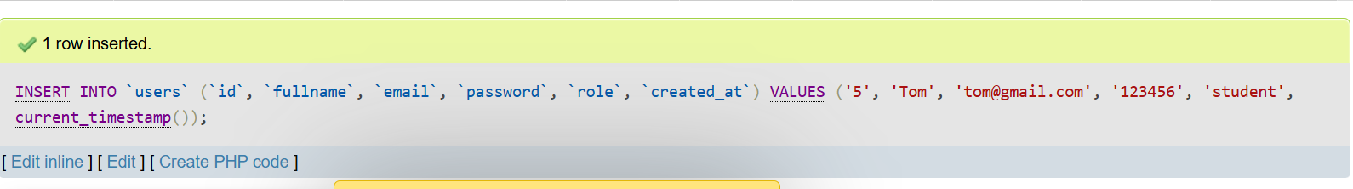
Figure 5.3: Inserting a new record into the users table (Create operation).

Read operation
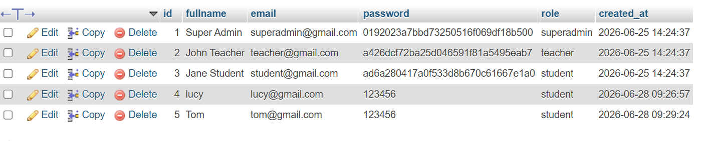
Figure 5.4: Records displayed in the users table (Read operation).

Update operation
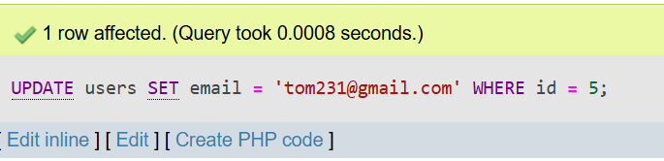

Figure 5.5: SQL UPDATE query used to modify an existing record in the users table

Delete operation
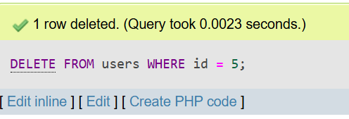

Figure 5.4: SQL DELETE query executed to remove a record from the users table.

LOGIN PAGE
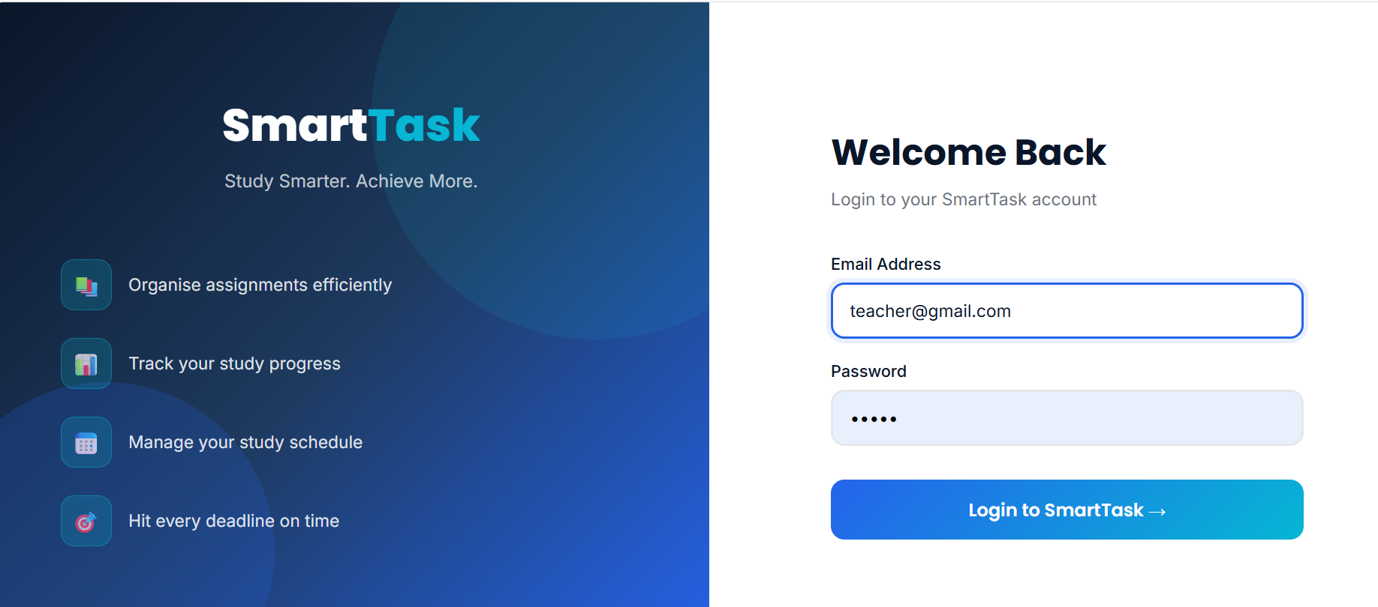

Figure 5.5: Login interface used for database authentication.

STUDENT EVALUATION
During Week 5 I learned how to create and manage databases using MySQL and phpMyAdmin. I created database tables, performed CRUD (Create, Read, Update, and Delete) operations and understood how SQL queries are used to manage data. I also learned how to integrate a login system with the database, which helped me understand how user information is stored and retrieved in a web application

Week 6 Database Integration and CRUD Operations

PHP Database Connection

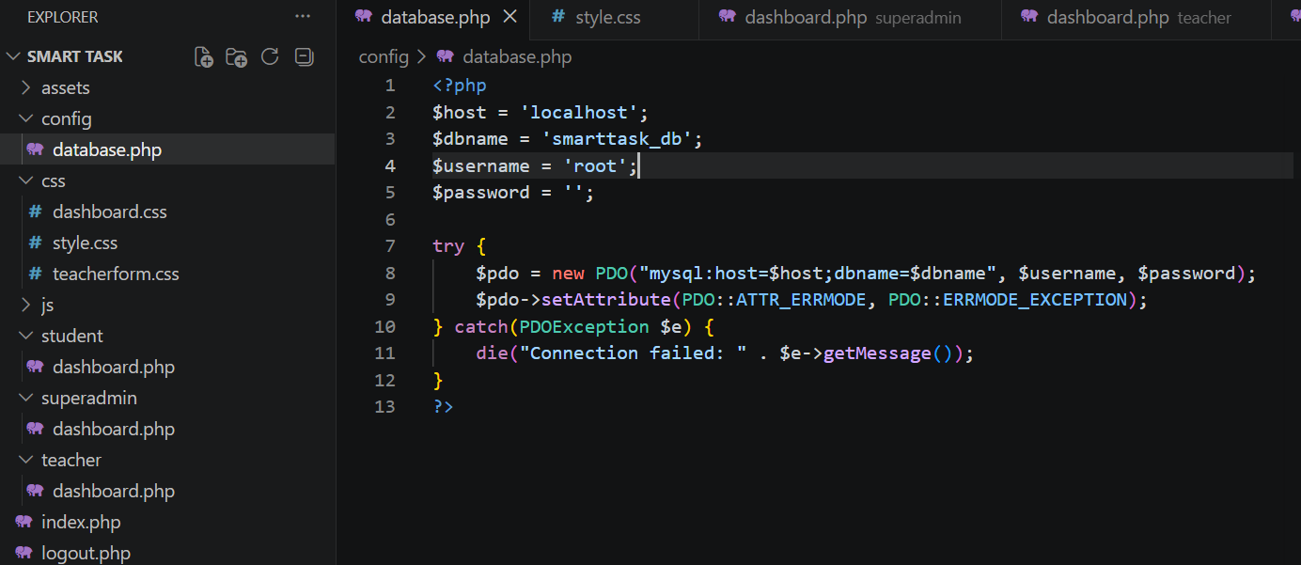

Figure 6.1: PHP script establishing a connection to the MySQL database.

Registration Task Form
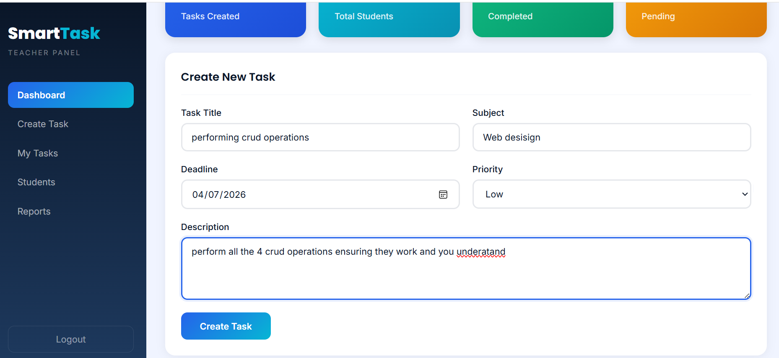

Figure 6.2: Data entry form used to create new records

Records Display
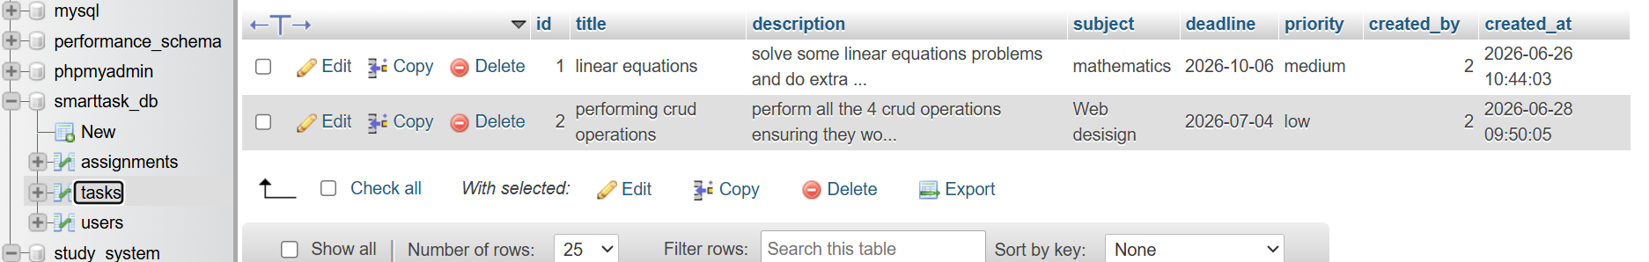

Figure 6.3: Records retrieved and displayed from the database.

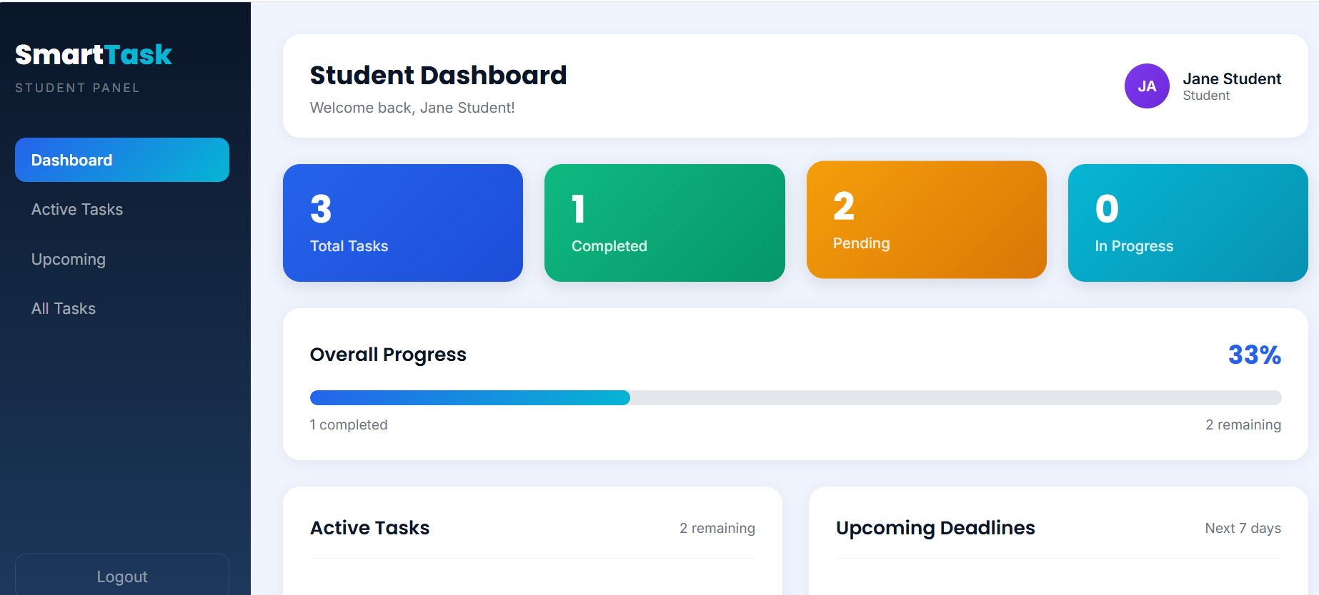

Figure 5.5: Successful user login demonstrating database integration between the web application and the MySQL database

STUDENT EVALUATION
During Week 6, I learned how to connect a PHP web application to a MySQL database and build database-driven features. I practiced retrieving, displaying, updating, and deleting records through the application and improved my understanding of backend development. I also learned the importance of testing, debugging, and validating user input to ensure the system works correctly and securely.

WEEK 7: User Authentication and Session Management

Users Table for Authentication
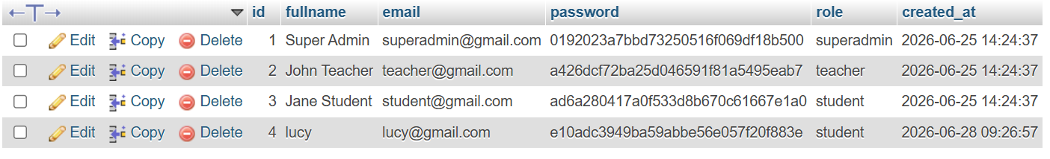
Figure 7.1: Users table containing user credentials, roles, and hashed passwords used for system authentication.

Student Authentication and Session Management
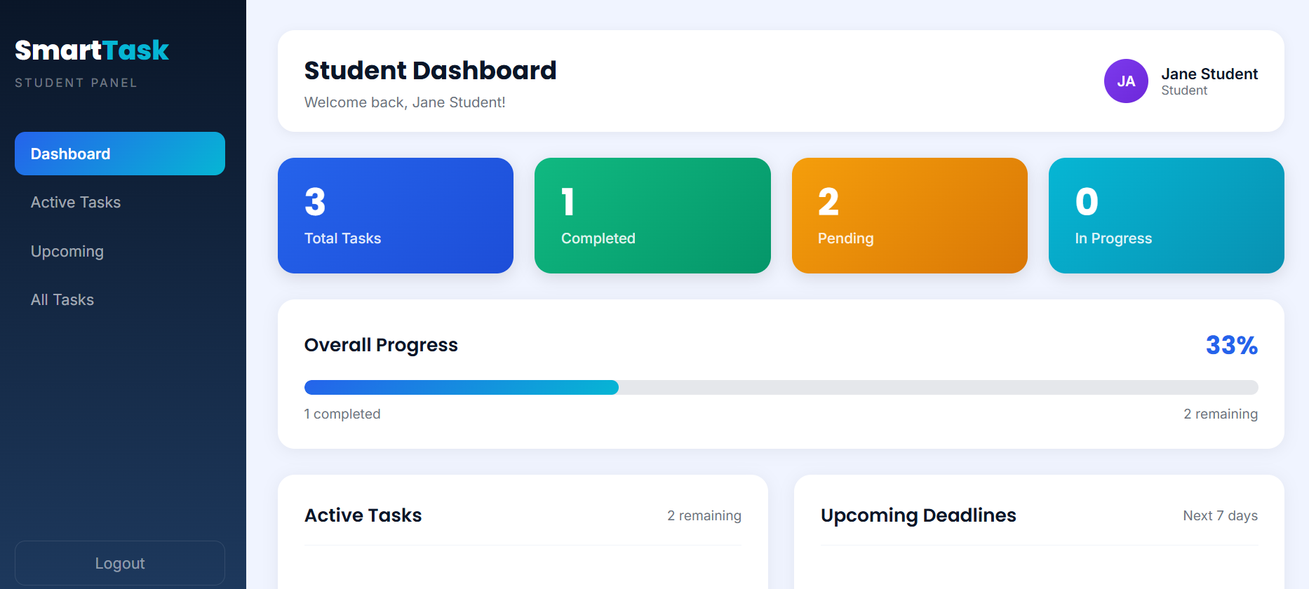
Figure 7.2: Successful student authentication demonstrating session creation and access to the student dashboard.

Teacher Role-Based Authorization
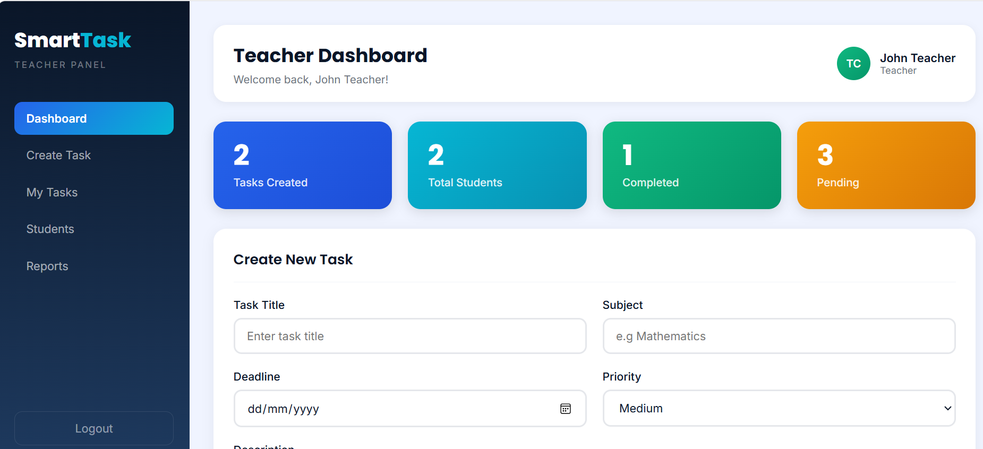
Figure 7.3: Teacher dashboard demonstrating role-based authorization after successful authentication.

Super Administrator Role-Based Authorization
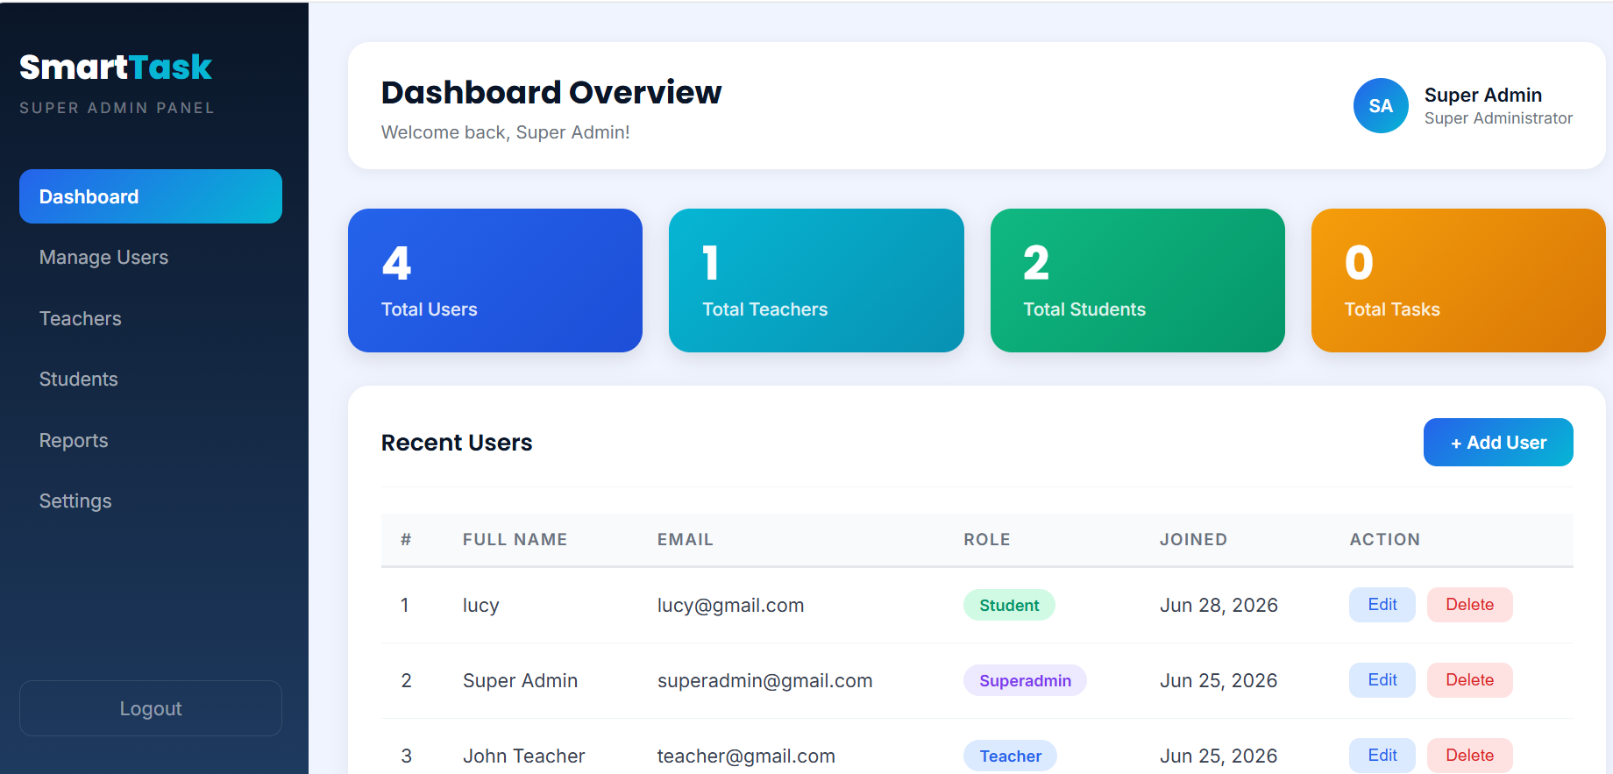
Figure 7.4: Super Administrator dashboard illustrating role-based access control and authenticated system privileges.

Logout Functionality
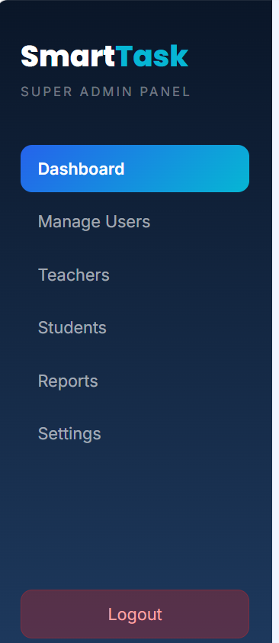 | 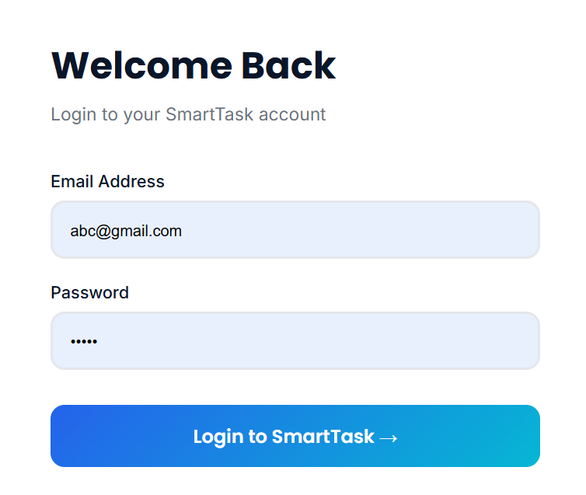

Figure 7.5: Logout functionality terminating the active user session and redirecting the user to the login page.

STUDENT REFLECTION
During Week 7, I learned how user authentication and session management are implemented in web applications to improve security. I gained practical experience with creating a secure login system, managing user sessions, and implementing role-based access control for different users such as students, teachers, and administrators. I also understood the importance of password hashing, protecting restricted pages from unauthorized access, and providing a secure logout mechanism. This week strengthened my backend development skills and enhanced my understanding of building secure and reliable web applications.

WEEK 8: Responsive Web Design and Mobile-First Development

Desktop View
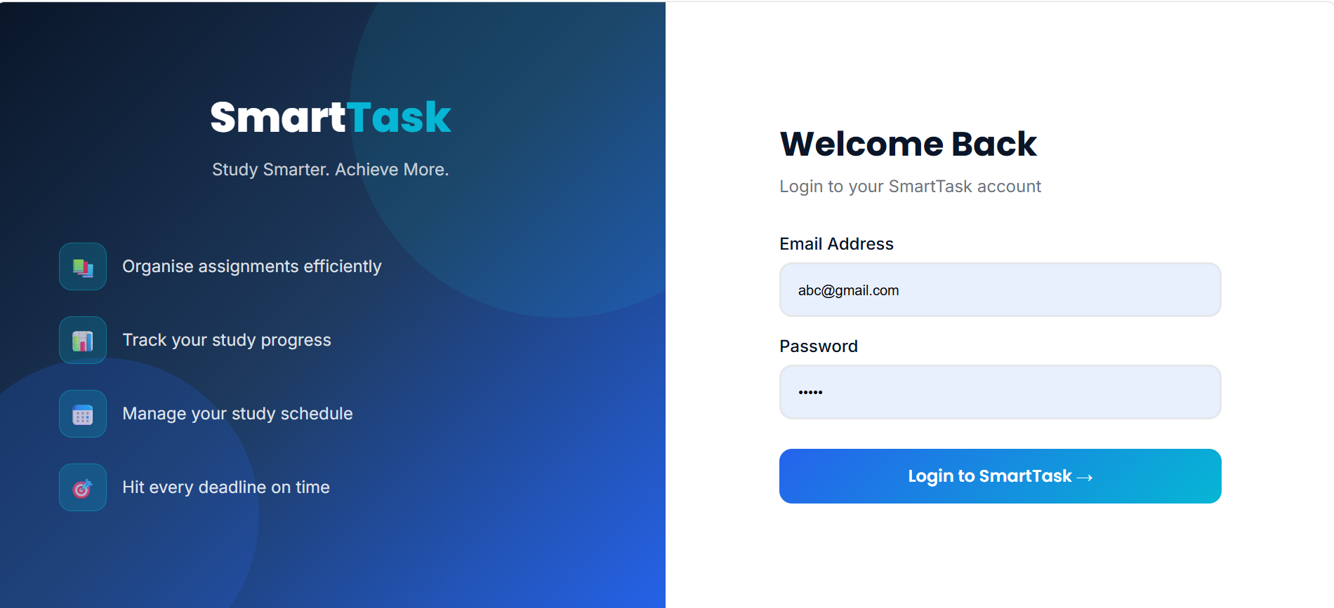
Figure 8.1: Desktop view showing full website layout using CSS Grid/Flexbox with side-by-side sections.

Tablet view
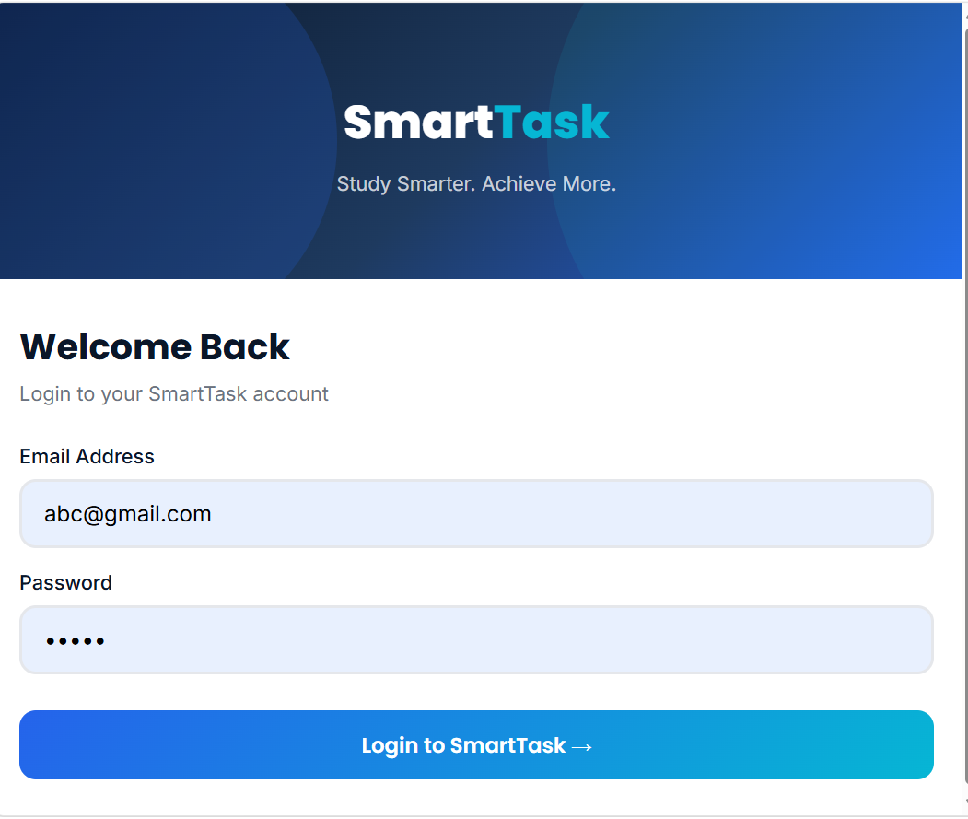
Figure 8.2: Tablet view demonstrating layout adjustment using media queries (768px breakpoint).

Mobile View (Mobile-First Design)
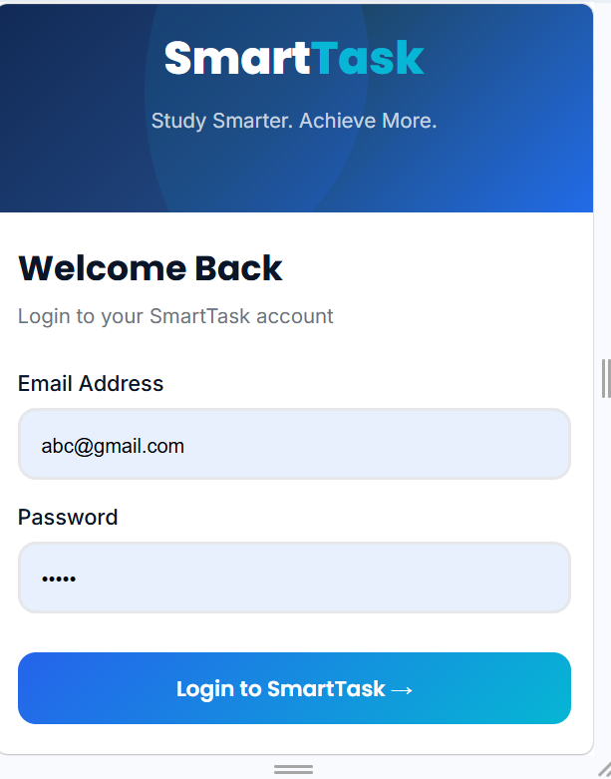
Figure 8.3: Mobile view showing single-column layout optimized for small screens.

CSS Media Queries Implementation
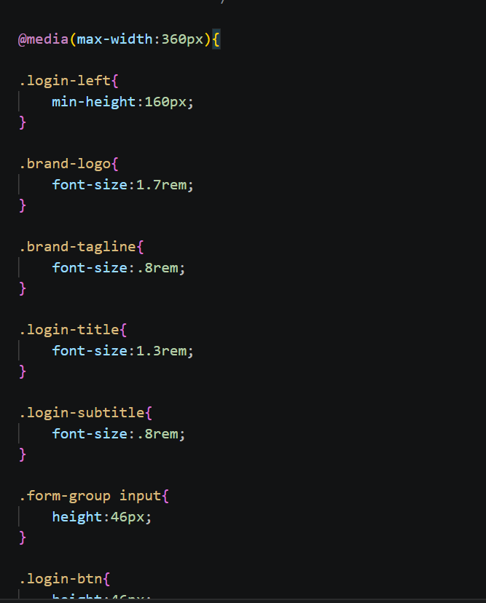
Figure 8.4: CSS code showing media queries used for responsive design and breakpoints.

Responsive Testing
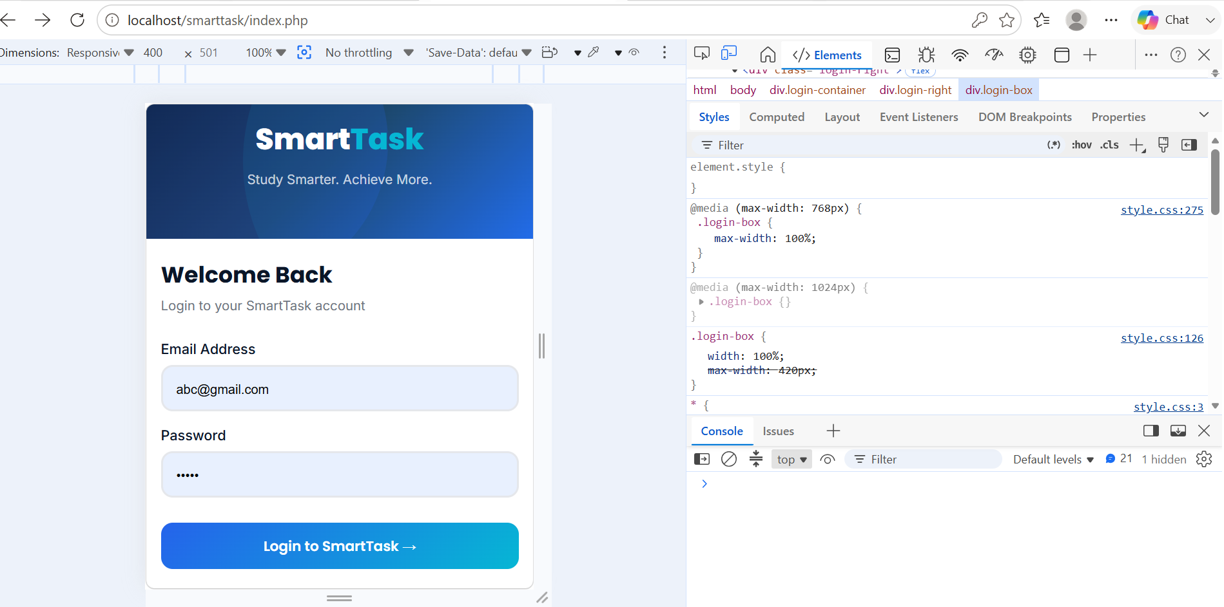
Figure 8.5: Chrome Developer Tools showing device toolbar used for testing responsive design.

Student reflection
This week, I learned about Responsive Web Design and Mobile-First Development. I understood how websites can adjust to different screen sizes using CSS media queries, Flexbox, and Grid.I also learned the importance of designing for mobile devices first to ensure better user experience. Additionally, I practiced testing responsiveness using Chrome Developer Tools.
Overall, this week helped me understand how to create simple, flexible, and responsive web pages that work well on all devices.

